Submission Open Call for Films
Architektur.Film.Sommer 2017
A cooperation between Az W, wonderland – platform for european architecture and MuseumsQuartier Wien

Title of the film Director

Country of production Year of production Duration

Language Subtitles Website of the film

Submitted by

Street Postcode City Country

E-Mail Telephone

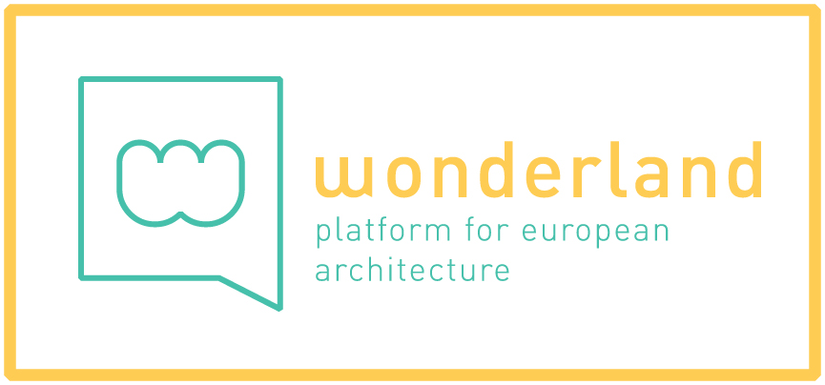
Short description

Has the film been shown at other events? If yes, where and when?

For further information please contact:
Karoline Mayer, mayer@azw.at, +43 1 522 31 15 / 28
Marlene Rutzendorfer, movies@wonderland.cx

Date: Signature:

